St. James’ in the Front Room, Selby
Good Friday Worship

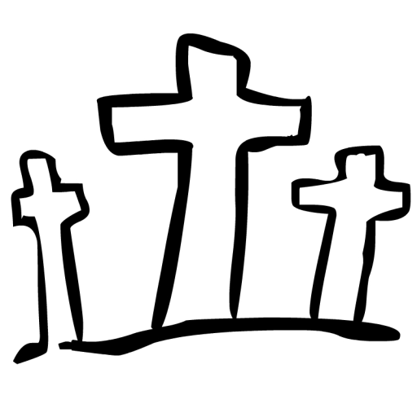

‘We all, like sheep, have gone astray, each of us has turned to his own way; and the Lord has laid on him the iniquity of us all.’
Isaiah 53:6

INTRODUCTION & WELCOME
‘St James in the Front Room - Good Friday Welcome’ https://youtu.be/EgCHs1GkL-E

SONG

‘How Deep the Fathers Love for Us - Stuart Townend’ www.youtube.com/watch?v=tzQj7XvKFmA

READ: Matthew 27:11-26
If you do not have access to a Bible you can find the passage using the following link. (Links are also given for subsequent readings):
www.biblegateway.com/passage/?search=matthew+27%3A11-26&version=NIVUK

REFLECTION
‘St James in the Front Room - Good Friday Reflection’ https://youtu.be/pqes3CLs1GE

SONG
‘The Power Of The Cross {with lyrics} - //Keith & Kristyn Getty, Stuart Townend’
https://www.youtube.com/watch?v=uS7fc7VTJZs
CREED
We believe in one God,
the Father, the Almighty,
maker of heaven and earth,
of all that is,
seen and unseen.

We believe in one Lord, Jesus Christ,
the only Son of God,
eternally begotten of the Father,
God from God, Light from Light,
true God from true God,
begotten, not made,
of one being with the Father;
through Him all things were made.
For us and for our salvation he came down from heaven,
was incarnate from the Holy Spirit and the Virgin Mary
and was made man.
For our sake he was crucified under Pontius Pilate;
he suffered death and was buried.
On the third day he rose again
in accordance with the Scriptures;
he ascended into heaven and is seated at the right hand of the Father.
He will come again to judge the living and the dead,
and his kingdom will have no end.

We believe in the Holy Spirit,
the Lord, the giver of life,
who proceeds from the Father and the Son,
who with the Father and the Son is worshipped and glorified,
who has spoken through the prophets.
We believe in one holy catholic and apostolic Church.
We acknowledge one baptism for the forgiveness of sins.
We look for the resurrection of the dead,
and the life of the world to come.
Amen.

READ: Matthew 27:27-44
https://www.biblegateway.com/passage/?search=matthew+27%3A27-44&version=NIVUK

CONFESSION
Lord Jesus Christ,
we confess we have failed you as did your disciples.
We ask for your mercy and your help.
Our selfishness betrays you:
Lord, forgive us.
Christ have mercy.
We fail to share the pain of your suffering:
Lord, forgive us.
Christ have mercy.
We run away from those who abuse you:
Lord, forgive us.
Christ have mercy.
We are afraid of being known to belong to you:
Lord, forgive us.
Christ have mercy.

We offer our sin to Jesus at the cross – a time of silent reflection

READ: Matthew 27:45-54
https://www.biblegateway.com/passage/?search=matthew+27%3A45-54&version=NIVUK

FINAL SONG

‘In Christ Alone by Stuart Townsend with Lyrics in HD’ www.youtube.com/watch?v=ouGuG97l2RY
CLOSING PRAYER
‘St James in the Front Room - Good Friday Close & blessing’ https://youtu.be/Fdmy_FSuaPY

