- Jesus the Warrior King
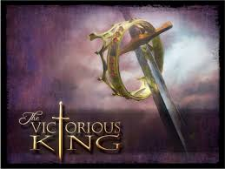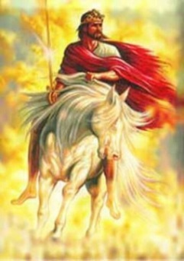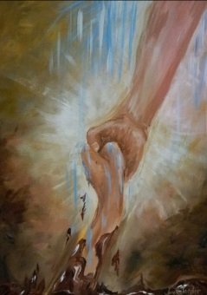
God of the Angel Armies, Chris Tomlin - https://www.youtube.com/watch?v=R0gu0nOaFsI
These are the Days of Elijah , Robin Mark - https://www.youtube.com/watch?v=ca9LnzJnpjQ
Paul Harcourt of New Wine comments on the effect of the Pandemic. We couldn’t meet together, did Satan think he had succeeded in stifling the church? No!! All the evidence suggests that more people are watching/listening to church in new forms than before! https://www.youtube.com/watch?v=E6rkmn9oks0&feature=youtu.be
Prayer: Lord, we pray for all those in Edge Community who have been working so hard to send out the message of your Gospel during this season of the pandemic; on social media, as worship, thought for the day & Kids Club, for Captain Richard & Kath, Amy, Mark & the team of volunteers. We pray that they will have times of refreshing after their input. Lord, we thank you for the response and for the number of children who have joined in. We pray for all those who have listened & shown interest, that they may deepen their faith and that you would shine your light into lives so that darkness will have to flee. Send forth your word Lord and let there be light! Amen.

Warrior King, Come set the captives free!
Prayer:
Lord, we pray for all those who are weighed down by darkness, who are “captive” in spirit and need to be set free. For those who are depressed and fearful, those who struggle with addiction, for those who have practised alternative religions or are “bound” in unhealthy relationships or sinful practises, Lord come and through prayer and your ministry at Edge, set the captives free!
Amen

Psalm 68:18 & Eph 4:8
When you ascended on high, you led captives in your train.
1 Samuel 17:47
King David said: “All those gathered here will know that it is not by sword or spear that the Lord saves; for the battle is the Lord’s, and he will give all of you into our hands”
Isaiah 61:1-2 NIV
The Spirit of the Sovereign Lord is on me,
because the Lord has anointed me
to proclaim good news to the poor.
He has sent me to bind up the broken hearted,
to proclaim freedom for the captives
and release from darkness for the prisoners.

