1A.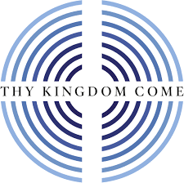 Thy Kingdom Come,
St. James the Apostle, Selby 2021
Thy Kingdom Come 2021 is here! As we emerge from the Pandemic, we are still using online methods to share in this season of prayer. Thank you for looking it up! This year it runs from 12th-23rd May. Do join us in prayer, it is so important and there is no better time to be praying, as so many people are coming to terms with change of every kind and when God’s top priority is building the Kingdom and inviting us to share in that process.
Thy Kingdom Come is a world-wide ecumenical prayer movement instigated by our Archbishops, so we are joining in with a large body of prayer. Justin Welby has asked if we would choose 5 people, friends/neighbours/relations to come to know the Lord & be empowered by his Holy Spirit. Don’t feel you have to stop on May 23rd!
Then, to pray for two other groups of people:
- Pray for those who have drifted, blessing them and calling them back in prayer. Prodigals.
- Pray for the “Tasters” to be drawn in, those influenced by the Church in the Pandemic, by eg. foodbanks, fellowship, debt help, online services & social media. Those who have never heard the Gospel.
One of the main Scriptures for this is Luke ch15….. Christ’s appeal of reconciliation to the lost.
How can you join in?
- You can go directly to the Thy Kingdom Come website : https://www.thykingdomcome.global/
There will be daily reflections and videos on there and resource material.
- You can access youth discussion materials if your family are interested
- There is also a daily “Cheeky Pandas” series running for younger folk
- We have our own daily reflection & prayer series for St James’s too.

Pray for your 5 people!

