Ascended, Reigning King, May Your Kingdom Come
10 days of prayer leading to Pentecost:
(21st May 2020 – 31ST May 2020, 10.30am each day)
…. on earth as it is in heaven ! ..
…. in our area of Selby as it is in heaven!
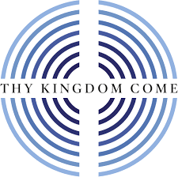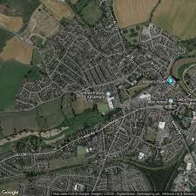
Edge Community &
Selby, North West,
Flaxley Rd Area
- Risen Jesus, Ascended King
“When Jesus had led them out to the vicinity of Bethany, he lifted up his hands and blessed them. While he was blessing them, he left them and was taken up in to heaven…ff.” Luke 24: v50-53
“Jesus said to them, go into all the world and preach the good news to all creation”. After the Lord Jesus had spoken to them, he was taken up into heaven and he sat at the right hand of God. Mark 16: v15 & 19
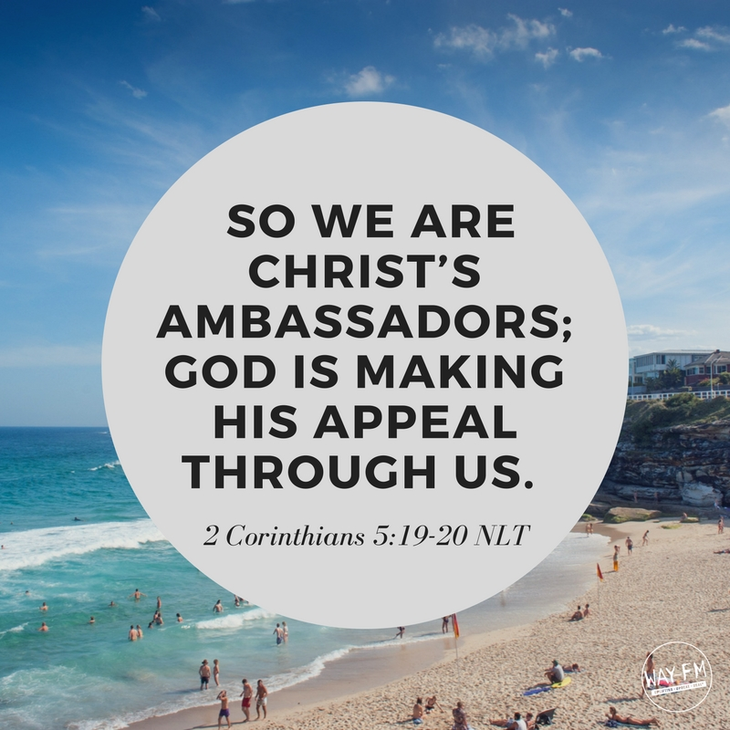
- Jesus the King
- Jesus the Warrior King
- Jesus the Good Shepherd
- Jesus the Promise Keeper
- Jesus Restorer & Healer
- Yours is the Kingdom, the Power & the Glory
- Your Kingdom is an everlasting Kingdom
- Step in to the Kingdom
10. May your Kingdom Come (on earth as it is in heaven)
11. Pentecost Sunday, Come Holy Spirit! .. …
See also Front Room Church & Edge Community worship
Acts 1 v 13 & 14 – When they had entered the city they went to the room upstairs, where they were staying, and they were constantly devoting themselves to prayer…. “We ask for God to give us help as we join in prayer with Christians around the world, that his love, made known in Jesus, may be made known in the areas we pray for.” Amen
(The Holy Spirit always has an address, speaking in our own language, thereby bringing about the specific work of Jesus Christ to certain individuals in different locations at distinct times. So, when we pray ‘Come Holy Spirit’ during Thy Kingdom Come 2020 we pray in this specific context of the COVID crisis, with all that we face, all that is unknown and all we are helpless before.)

