Thy Kingdom Come, Day 6
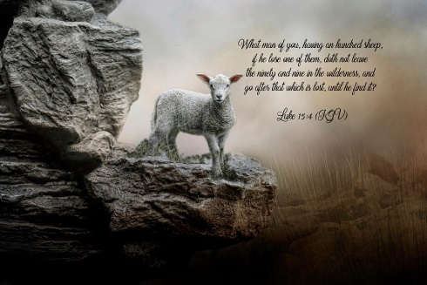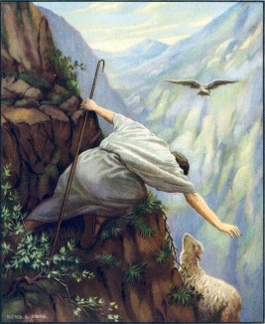
The Lost Sheep, Luke ch 15:1-7
“The Lost are Found” – Hillsong Chapel, https://www.youtube.com/watch?v=GX9gejtyptI
Reckless Love of God. The Price is paid, https://www.youtube.com/watch?v=7GGJ8cyYNzQ Cory Astbury
He joyfully puts the sheep on his shoulders and brings it home. Then he calls his friends and neighbours together and says “Rejoice with me, I have found my Lost Sheep”
One Lost Sheep
On a field trip, crossing the limestone pavement above Malham Tarn, some students in the party found a sheep stuck down a gryke, a fissure, in the pavement, quite a long way down. It was in a poor way, dull-eyed and emaciated, it must have been there a long time, all its resistance had gone. They were really concerned, bottles of water, hand fulls of grass, everything was going to try to assist it, but it seemed to have gone past it. A few of them went to the roadside to flag down any farmer passing by to ask who the sheep belonged to?
No one seemed to be about. So then they decided to ease it out of its entrapment. Off came some of their clothes to make straps to pass underneath it and to use as hoists to get it out. One herculean pull from several of them pulled it up on to the pavement for the first time in days. It could hardly stand up, wobbling everywhere, but then it stumbled back to join the more nimble flock. The Lord would leave ninety nine others to seek the one.

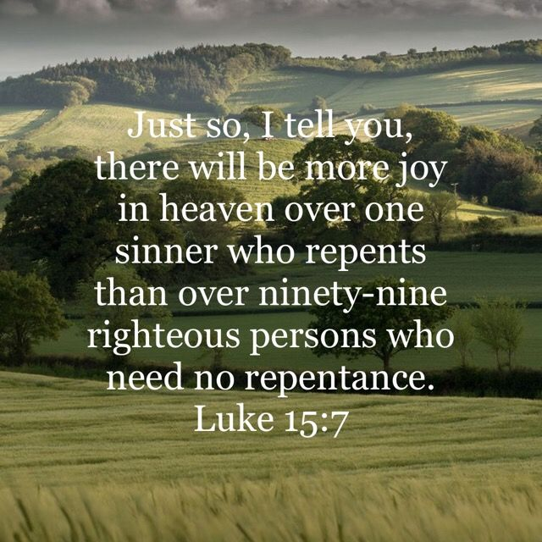

Father God, we thank you that you are the Good Shepherd and you will seek out the Lost. We pray for our 5 people. We pray for those who don’t know you and have strayed away from you and we ask for them to know by your Spirit how much you care for them and for them to repent and turn towards you. We pray that they may know the God-given joy from heaven and a sense of you rejoicing over them. We pray for that mission in the Edge Community & Ace Active Ministries & emerging church and as each of us prays. Amen.
Amen
