1. **Yours is the Kingdom, the Power & the Glory**

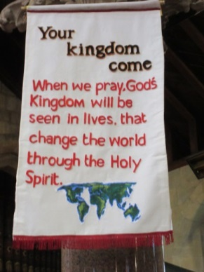 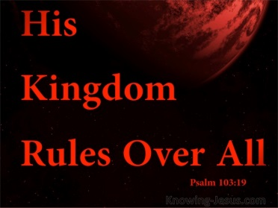  

<https://www.youtube.com/watch?v=mA2q295l9A0> - Your Kingdom Come, Pete James 2018

<https://www.youtube.com/watch?v=sbdJXKqVgtg> – Rend Collective. Build your Kingdom

**Reflection:**

**What is your Kingdom? Where is your Kingdom? Who has your Kingdom?**

**The fourth picture was passed around recently and was obviously a hint at “God’s own County”, but there is a certain truth in it! Where is God in the crisis? He’s right there on the estate! It is his home too! He created the land, wants to take back ownership, he is in many people and wanting to visit more.**

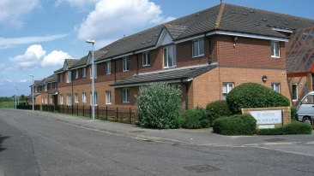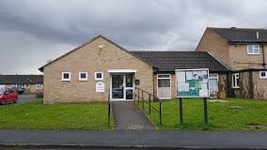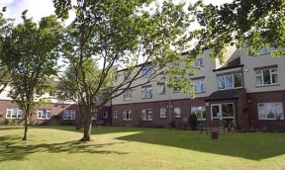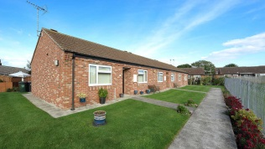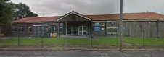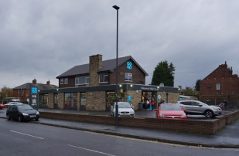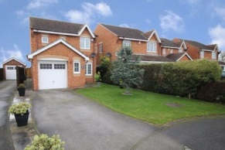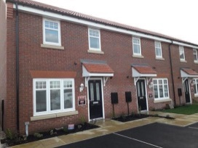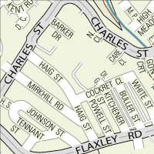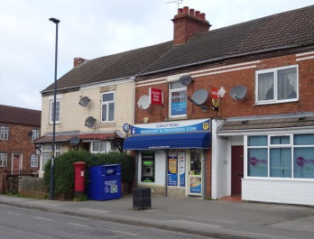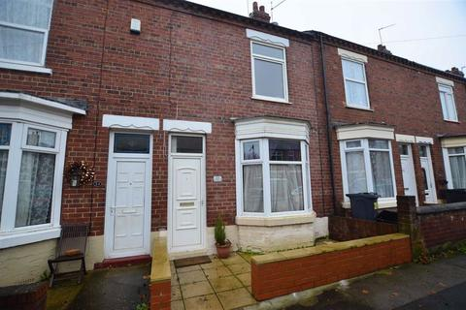

**Lord, you yourself talked and taught at length about the Kingdom of God, the early disciples were challenged to go and tell the Good News of the Kingdom of God. We pray “Your Kingdom Come” in this area of Selby. We pray for the businesses and shops in this area, for the meeting centres and halls, for the schools, for the foodbank, medical workers & keyworkers, that you will be at work in them. If they have been affected by the issues of the pandemic, Lord, we ask for restoration and wisdom in re starting, for financial assistance where necessary. Thank you for teachers who have worked during this time, help them, Lord, and the schools as they start to return in some form in June. Pray that a right spirit would prevail and a greater sense of emerging community. Bless the society as a whole and “set it back on its feet”. Recall people, speak to people, hear the cries of your People, Thy Kingdom Come we pray! Amen.**

**Amen.**

**King David’s Prayer - Yours, Lord, is the greatness and the power and the glory and the majesty and the splendour for everything heaven and earth is yours. Yours, Lord, is the kingdom: you are exalted as head over all.  
Wealth and honour come from you; you are the ruler of all things. In your hands are strength and power to exalt and give strength to all. Now, our God, we give you thanks, and praise your glorious name. Amen ….**

**Edge’s” hidden Kingdom”**

**We give thanks to you to you for all who support Edge, all who have been on mission there & ministered there past & present. We thank you for those who provide individually funding and resources & for Church Army. We ask that you will continue to provide in this time of uncertainty and bless their provision. Help us to send out news of Edge, so that they will know how to respond. Amen.**

**.**